Assignment 3

|  |  |
| --- | --- |
| Assignment Date | 04 November 2022 |
| Student Name | K.RAJESH |
| Student Roll Number | 422119104020 |
| Maximum Marks | 2 Marks |

# Question 1:

Create a bucket in IBM object storage.

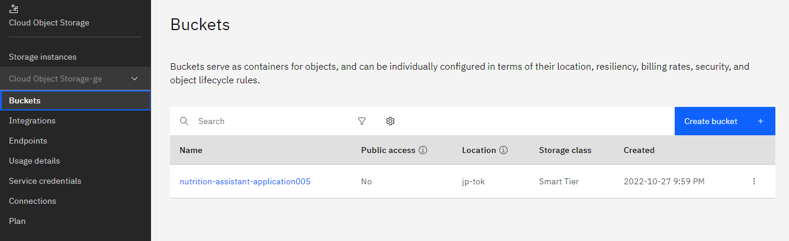

# Question 2:

Upload any 5 images to IBM object storage and make it public. Write HTML code to displaying all the 5 images

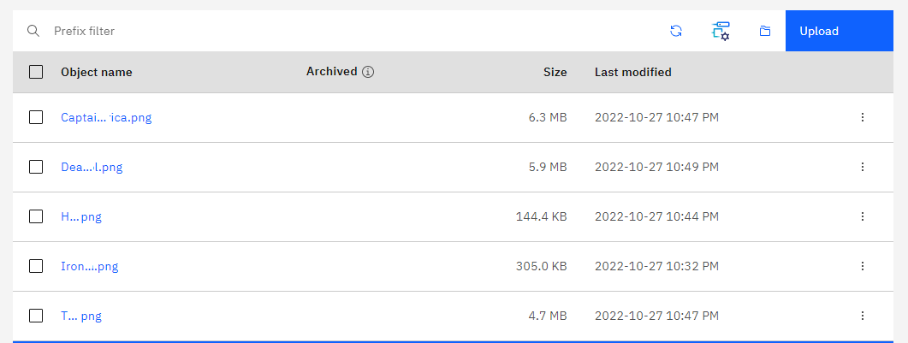

HTML code for displaying images in cloud

<!DOCTYPE html>

<html lang="en">

<head>

    <meta charset="UTF-8">

    <meta http-equiv="X-UA-Compatible" content="IE=edge">

    <meta name="viewport" content="width=device-width, initial-scale=1.0">

    <title>Marvel</title>

    <link rel="stylesheet" href="style.css">

</head>

<body>

    <h1>Marvel Heros</h1>

    <h2>1 Iron Man</h2>

    <img src="https://nutrition-assistant-application005.s3.jp-tok.cloud-object-storage.appdomain.cloud/Ironman.png" alt="Iron Man" width="250" height="300">

    <h2>2 Thor</h2>

    <img src="https://nutrition-assistant-application005.s3.jp-tok.cloud-object-storage.appdomain.cloud/Thor.png" alt="Thor" width="500" height="600">

    <h2>3 Captain America</h2>

    <img src="https://nutrition-assistant-application005.s3.jp-tok.cloud-object-storage.appdomain.cloud/Captain%20America.png" alt="Captain America" width="500" height="600">

    <h2>4 Hulk</h2>

    <img src="https://nutrition-assistant-application005.s3.jp-tok.cloud-object-storage.appdomain.cloud/Hulk.png" alt="Hulk" width="500" height="600">

    <h2>5 Dead Pool</h2>

    <img src="https://nutrition-assistant-application005.s3.jp-tok.cloud-object-storage.appdomain.cloud/Deadpool.png" alt="Dead Pool" width="500" height="600">

</body>

</html>

HTML Output for displaying images from IBM cloud storage:

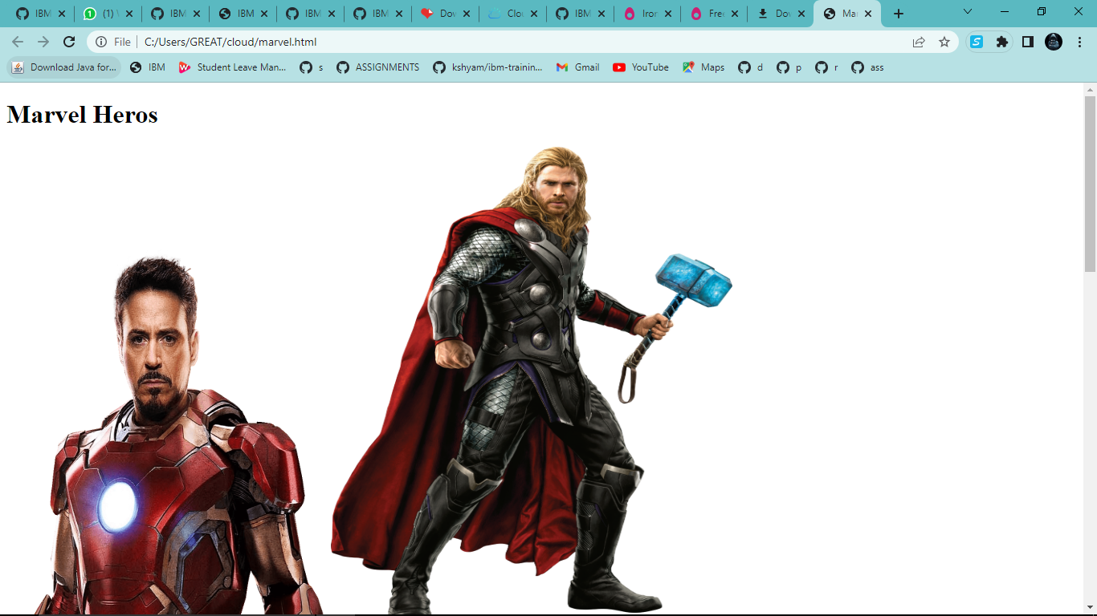

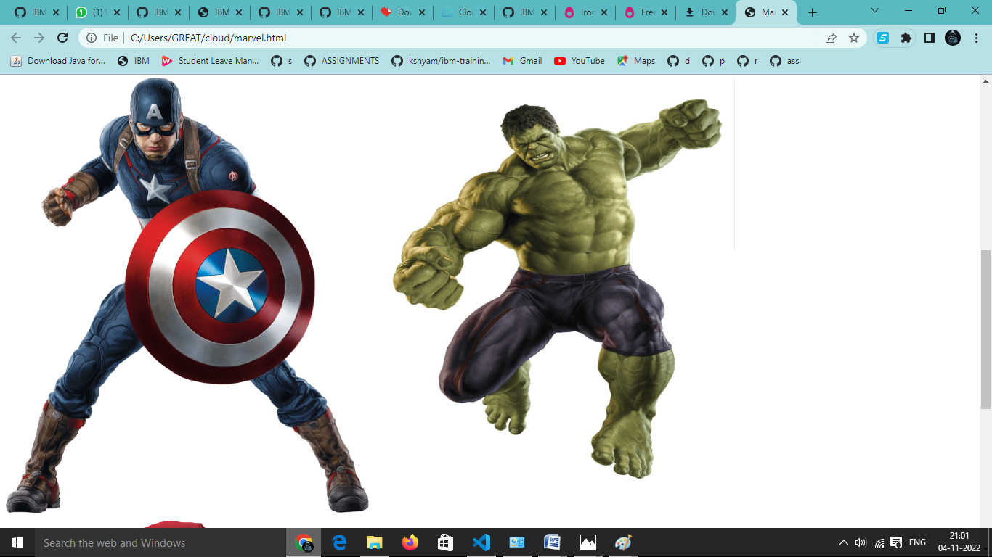

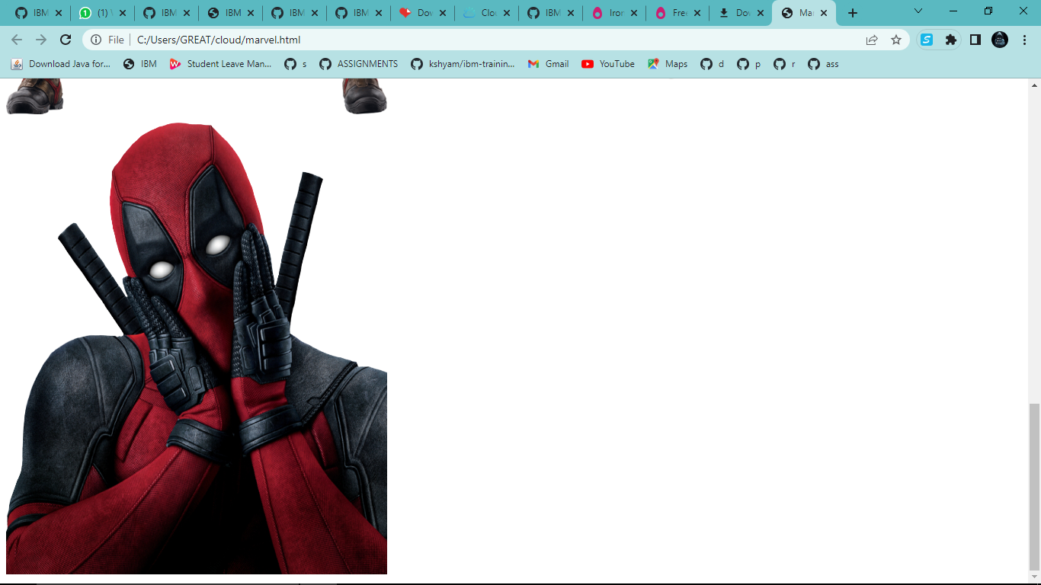

# Question 3:

Upload a CSS page to the object storage and use the same page in your HTML code.

Style.css

*{

    background: linear-gradient(aqua,white,red);

    align-items: center;

    justify-content: center;

}

img{

    border-radius: 70px;

    border-color: #fff;

}

Output:

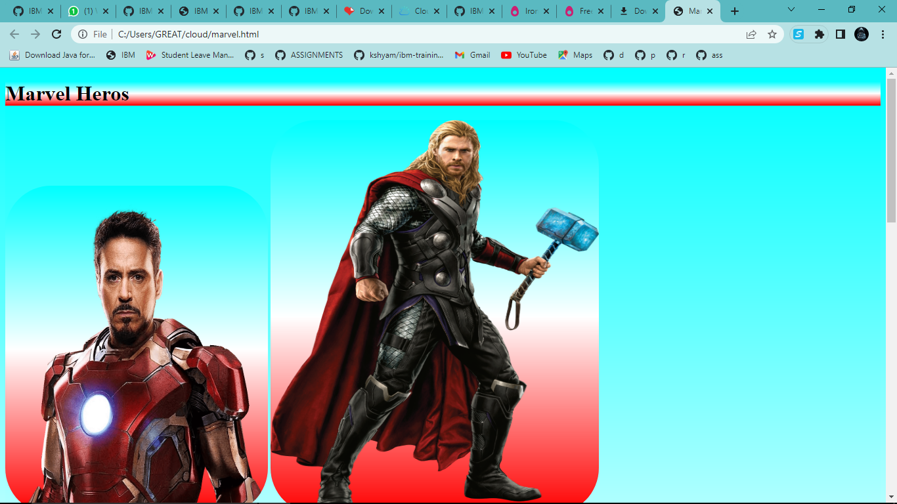

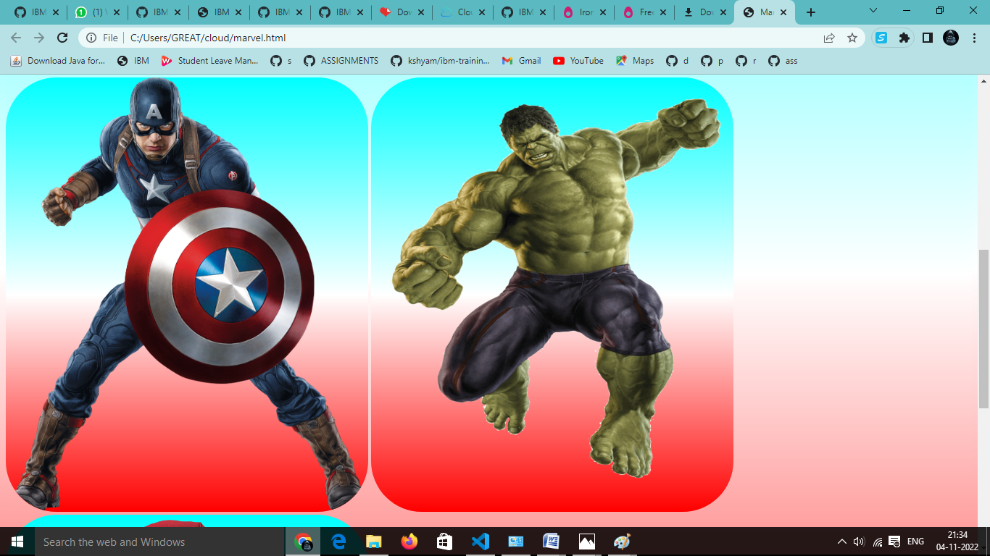

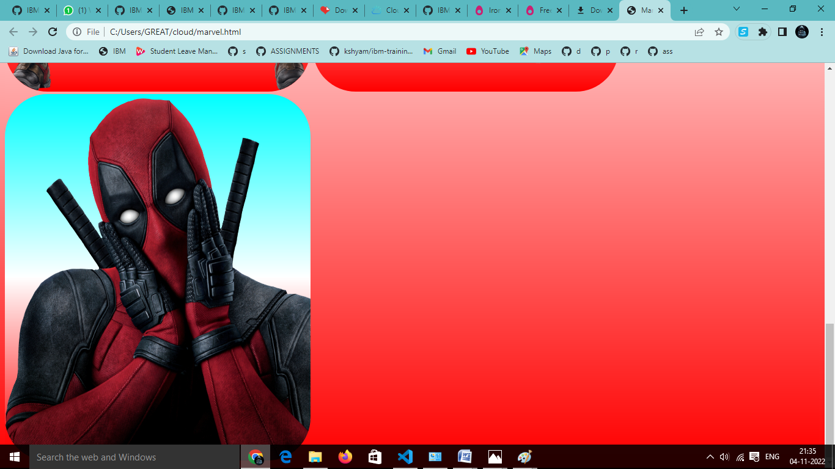

CSS ﬁle in Cloud object storage

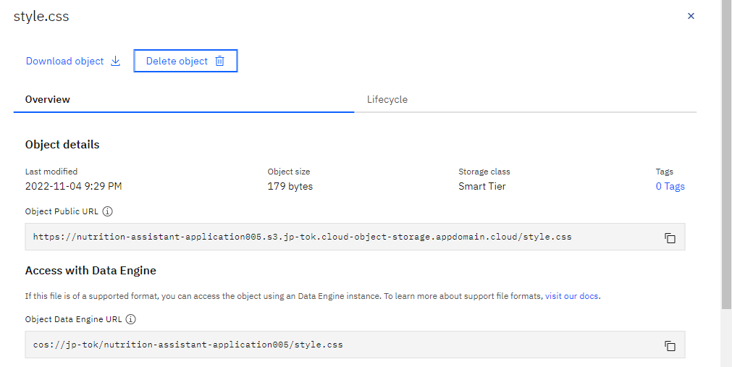

# Question 4:

Design a chatbot using IBM Watson assistant for hospital. Ex: User comes with query to know the branches for that hospital in your city. Submit the web URL of that chat bot as a assignment.

# Web URL of chat box:

https://webchat.global.assistant.watson.appdomain.cloud/preview.html?backgroundImageURL=https://jptok.assistant.watson.cloud.ibm.com/public/images/upx-f3a1f015-5572-4204-96b6-7c25f885ddc6::156bcb72-665e-46b3-872e-a17217657433&integrationID=d2b53d34-6e0e-4d81-b157ae1023cd641a&region=jp-tok&serviceInstanceID=f3a1f015-5572-4204-96b6-7c25f885ddc6

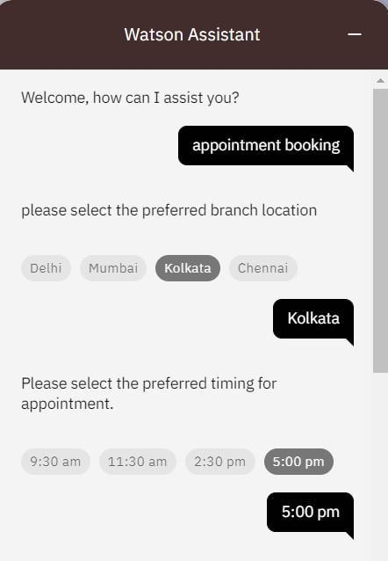

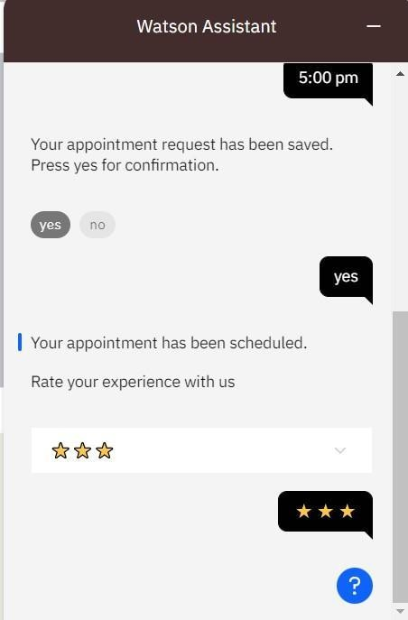

# Question 5:

Create Watson assistant service with 10 steps and use 3 conditions in it. Load that script in HTML page.

Script in HTML page:

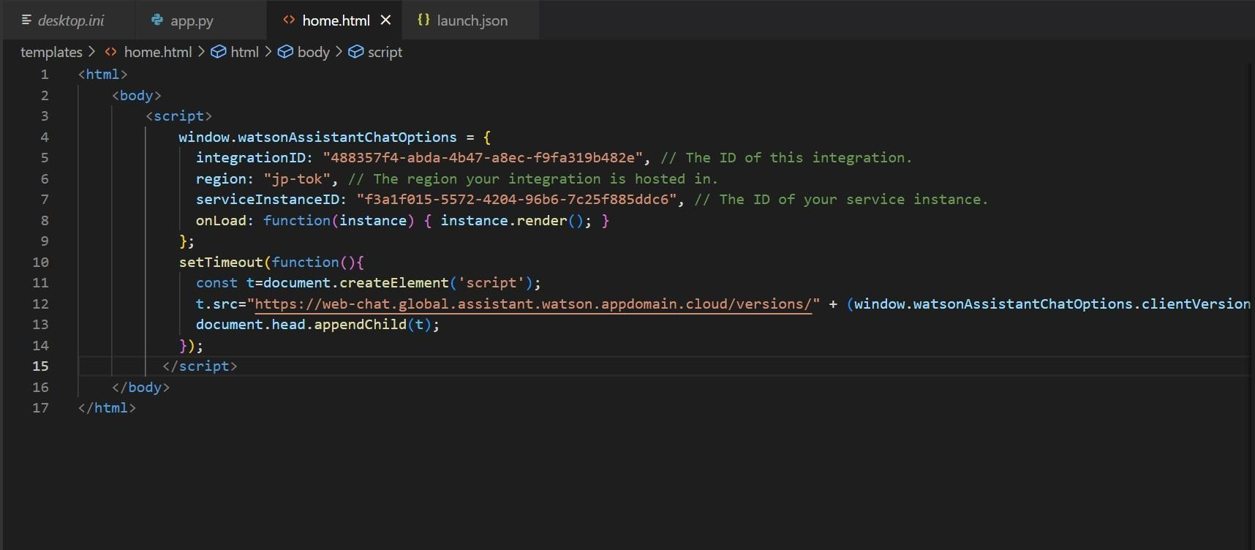

Food-ordering bot:

